29.61: a)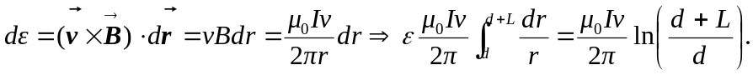
b) The magnetic force is strongest at the top end, closest to the current carrying wire. Therefore, the top end, point a, is the higher potential since the force on positive charges is greatest there, leading to more positives gathering at that end.
c) If the single bar was replaced by a rectangular loop, the edges parallel to the wire would have no emf induced, but the edges perpendicular to the wire will have an emf induced, just as in part (b). However, no current will flow because each edge will have its highest potential closest to the current carrying wire. It would be like having two batteries of opposite polarity connected in a loop.

